**COMP2012 (Fall 2022) Discrete Mathematics**

Quiz 3. 15:00pm-16:00pm, 30th November 2022

Name: __________________ Student ID: ________________ Marks: / 100

* This is an **individual** quiz.
* Please submit the **soft copy** of your answer to Blackboard (as a doc/docx/pdf file).

**Question 1 [40 marks]**

**1(a)** Traverse the following Binary Search Tree (BST). List the *in-order* (5 marks), *pre-order* (5 marks) and *post-order* (5 marks) of the traversal.

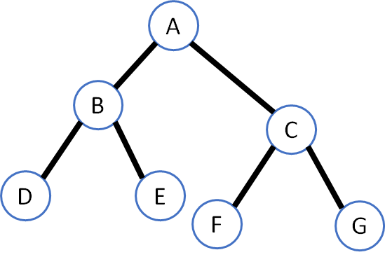

**1(b)** Use the postfix expression below to form a binary tree (15 marks), then write the prefix form (5 marks) and the infix form (5 marks) of this tree.

ED-CBA+**

**Question 2 [60 marks]**

This question is about Boolean algebra and circuits.

**2(a)** Write down the logic expression at the points (i) to (v) for the following circuit. (15 marks).

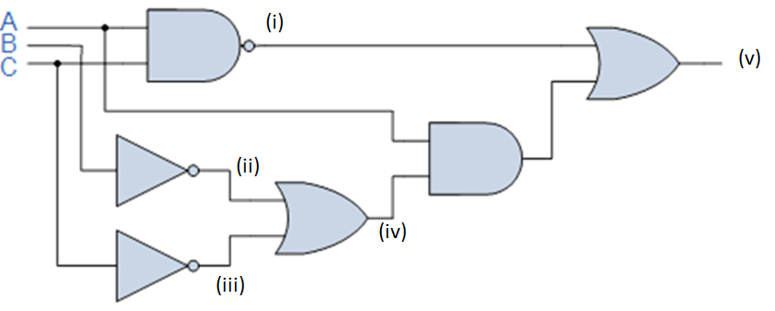

**2(b)** Express *F*(*A*, *B, C*) = *A ⋅ B* + ($\overline{A C}$*)* by using a combinational circuit with NOR gates only (20 marks)

**2(c)** Simplify the following expression using K-map (25 marks)

*F(A, B, C) = $A\overline{B}C+\overline{A}BC+AB+\overline{AB}C$*

End of Quiz 3